 | Testing and Training Center of Farm Machinery  Department of Farm Machinery and Power Engineering  College of Agricultural Engineering and Technology  Junagadh Agricultural University  JUNAGADH – 362 001 (GUJARAT) | 
P | Phone : (0285) 2672080-90, Ext. 390 & 484; Fax : (0285) 2671018

SPECIFICATION SHEET OF TRACTOR OPERATED POTATO DIGGER

1.0 | General | :
 | Name of machine | :
 | Name and address of manufacturer | :
 | Name and address of applicant | :
 | Selling price in India | :

2.1 |  | Main frame:
 | a) |  |  | Type and material | :
 | b) |  |  | Size (mm) | :
2.2 |  | Blade:
 |  | a) |  | Type and material | :
 |  | b) |  | Number | :
 |  | c) |  | Width (mm)
 |  |  |  | Side blade | :
 |  |  |  | Centre blade | :
 |  |  |  | Total | :
 |  | d) |  | Inclination, Min. and Max. | :
 |  | e) |  | Clearance from ground (mm) | :
 |  | f) |  | Clearance from transmission shaft casing (mm) | :
 |  | g) |  | Thickness (mm) | :
 |  | h) |  | Distance from centre to centre of blades (mm) | :
2.3 | Elevator chain conveyor :
 | a) |  | Material |  | :
 |  |  | Size (mm)
 |  |  | Length |  | :
 |  |  | Width |  | :
 | b) |  | Pitch |  | :
 | c) |  | Chain rod diameter (mm) |  | :
 | d) |  | Number of rods |  | :
 | e) |  | Flat belt width joining the road (mm) |  | :
 | f) |  | Slope
 |  |  | Front side |  | :
 |  |  | Rear side |  | :
2.4 | Disc :
 | a) |  | Material |  | :
 | b) |  | Size (mm) |  | :
 | c) |  | Number |  | :
 | d) |  | Spacing (mm) |  | :
 | e) |  | Hub diameter (mm) |  | :
2.5 | Transmission : |  |  |  | :
 | a) |  | Front pulley diameter (mm) |  | :
 | b) |  | Rear pulley diameter (mm) |  | :
 | c) |  | V-belt size, number |  | :
 | d) |  | Gear box reduction ratio |  | :
 | e) |  | V-belt lightener, width (mm) |  | :
 | f) |  | Dia. of casing of output shaft (mm) |  | :
 | g) |  | Dia. of rear drive shaft (mm) |  | :
 | h) |  | Dia. of idler shaft (mm) |  | :
 | i) |  | Dia. of agitator shaft (mm) |  | :
 | j) |  | Dia. of idler roller shaft (mm) |  | :
 | k) |  | Dia. of front idler (mm) |  | :
 | l) |  | Driving sprocket teeth (Nos.) |  | :
2.6 | Safety features :
 | a) |  | PTO guard |  | :
 | b) |  | V-belt guard |  | :
2.7 | Type of hitch and its details :
 | a) |  | Type and material |  | :
 | b) |  | Shape |  | :
Specification of Hitch Pyramid As per IS: 4468-1997 (Part-I)

Sr. | Dimension  (Refer Fig.1) | Description | Measurement
Upper Hitch attachments
1 | d₁ | Diameter of hitch pin hole
2 | b’₁ | Width between inner faces of yoke
3 | b’₂ | Width between outer faces of yoke
Lower hitch points
4 | D₂ | Dia. of hitch pin
5 | b’₃ | Linch pin hole distance
6 | l | Lower hitch point span
Other dimensions
 | Diameter of linch pin hole
7 | d | For upper hitch pin
8 |  | For lower hitch pin
9 | h | Mast height

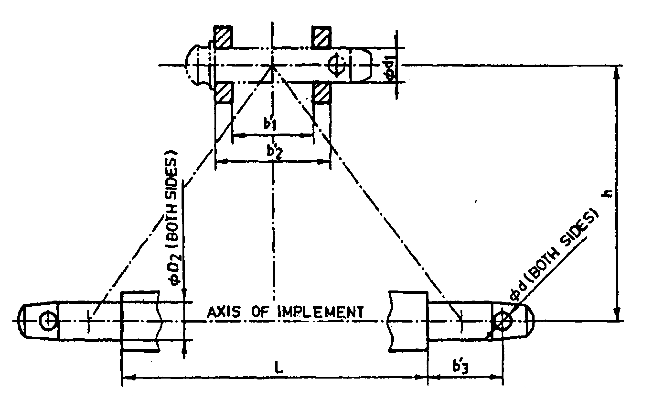
Fig. 1 : Implement Hitch Attachment
2.8 | Spline end of digger input shaft: |  | Ref. Fig.2

 | a) |  | PTO Type and material | :
 | b) |  | Nominal speed (rpm) | :
 | c) |  | Nominal dia.(mm) | :
 | d) |  | Number and type of splines | :
Dimension of Implement Power Input Shaft As per IS: 4931-1995

Sr. |  | Specification/ Notations  (Refer Fig.2) |  |  |  | Measurement
1 |  | PTO Type
2 |  | Nominal speed (rpm)
3 |  | Nominal dia.(mm)
4 |  | Number and type of splines
Dimensions (mm)
5 |  | D Φ
6 |  | d Φ
7 |  | B Φ
8 |  | A Φ
9 |  | W
10 |  | a
11 |  | b
12 |  | c
13 |  | x
14 |  | B
15 |  | h

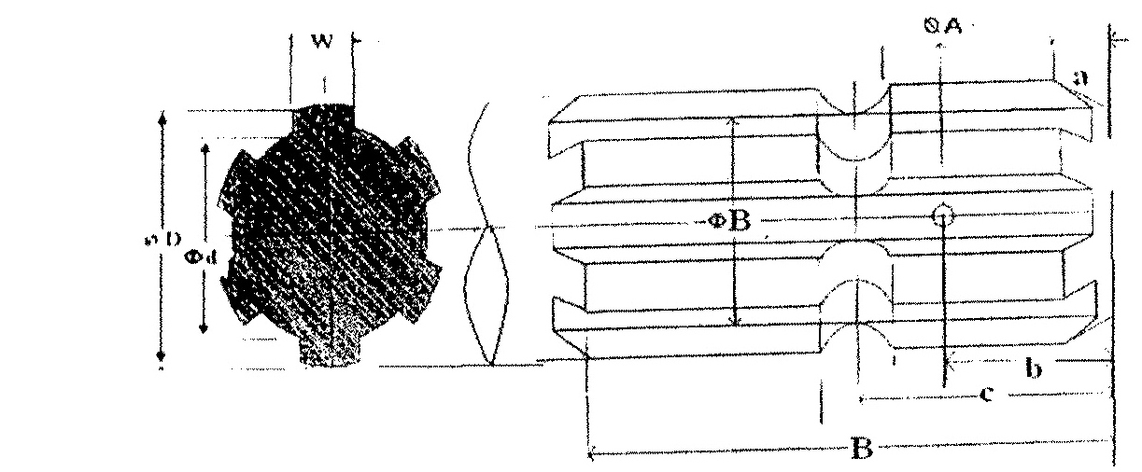

Fig. 2 Dimension of Implement Power Input Shaft

2.9 | Propeller shaft:
 | a) | Type and material | :
 | b) | Length of shaft (mm)
 |  | Minimum | :
 |  | Maximum | :
 | c) | Mass of shaft (kg) | :
 | d) | Provision for locking | :

Propeller Shaft Insert Dimensions As per IS: 4931-1995

Sr. | Notations  (Refer Fig.3)
1 | D Φ
2 | d Φ
3 | W
4 | B
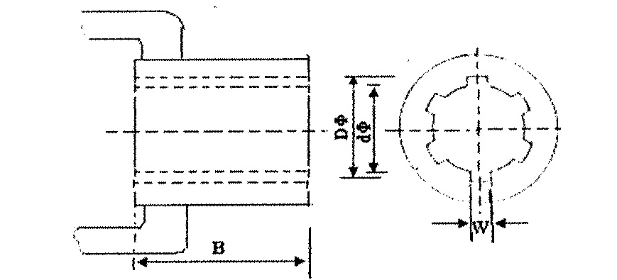
Fig. 3 : Propeller Shaft Insert Dimensions
2.10 | Rear support wheel:
 | a) | Material |  | :
 | b) | Size (mm) |  | :
3.0 | Overall Dimensions (mm)
 | a) |  | Length | :
 | b) |  | Width | :
 | c) |  | Height | :
 | d) |  | Mass, (kg) | :
4.0 | Any other mechanism/facility |  |  | :

4.0 | Details of Material of Construction :
Sr. | Name of part | Material | Section or size in mm
1 | 2 | 3 | 4
1 | Frame
2 | Elevator chain
3 | Blade
4 | Disc
5 | Main shaft
6 | Idler shaft
7 | Agitator shaft
8 | Sprocket
9 | Pulley

Place:
Date:
Signature : _________________________

Name : _________________________

Designation: ________________________

